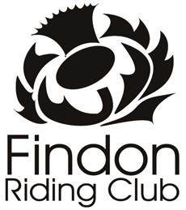
Findon jackets

We are offering Navy soft shell jackets for the club they will have our logo on the left chest and, if you wish, on the back they can be personalised.
Name
Male or Female
Size (XS, S, M, L, XL, XXL)
Personalised, optional (e.g. Neco)
£5 extra

The jackets will be £35 each or £40 for the personalised extra.
Please tick :
Bank transfer
Cheque
Cash
Return via email to dorothy.burnett1@btinternet.com

